Academy quiz part 2
AF1 level 5H cells context
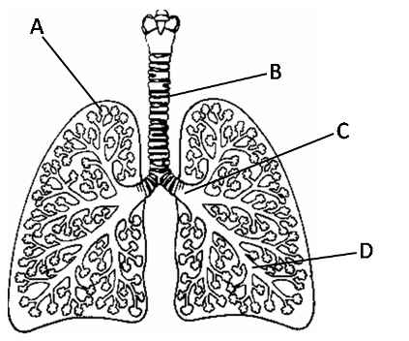
- The diagram below shows part of the human respiratory system.

- Which letter shows the tube that takes air to the lungs (trachea)?
- Which shows one of the narrow tubes that carries air
throughout the lungs (a bronchiole)?
- Which two parts are covered with mucus?
- What is part A?
4 marks
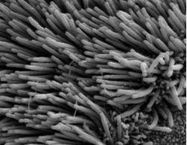
- The cells that line parts B and C look like this from above.
What does the image show, and what is their role?
4 marks
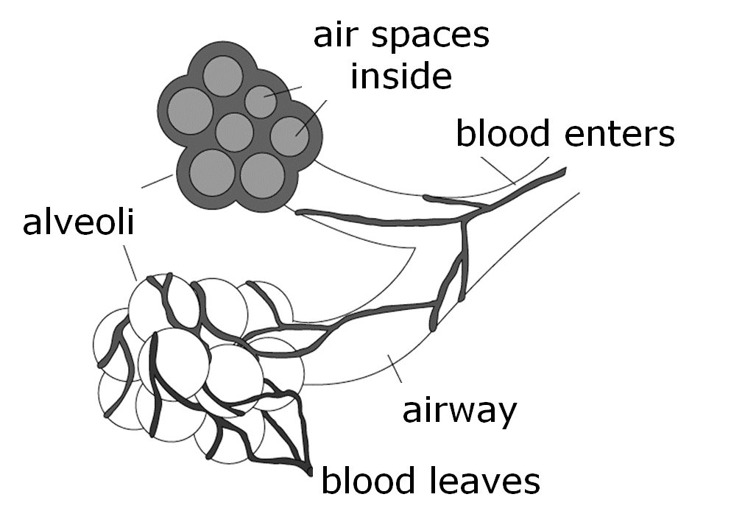
- This diagram shows the alveoli in close-up.

- Alveoli are specialised tissues. What are they designed to do?
- Which features make alveoli perfect for the job?
4 marks
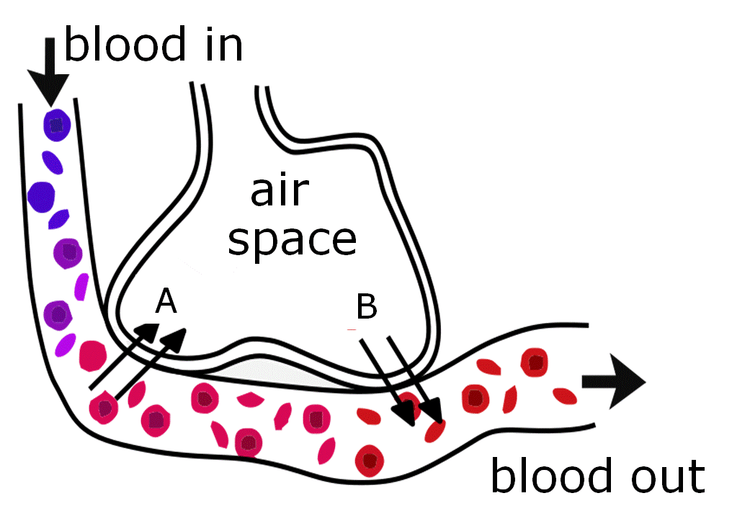
- This diagram shows a cross section through part of an alveolus.

The arrows show which way A and B diffuse.
Name these two gases.
2 marks

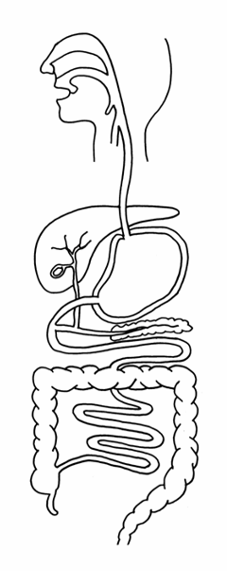
- After a meal, your blood picks up nutrients from
the small intestine. Explain how its inner wall
is specialised to aid absorption.
2 marks
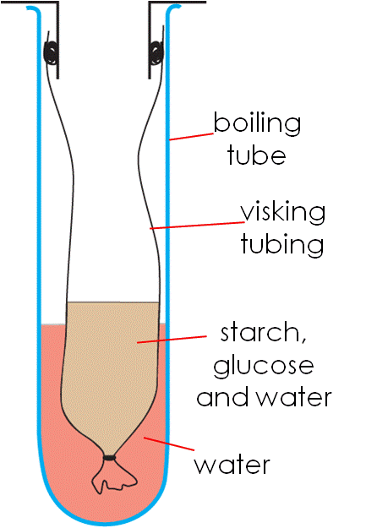
- Katie and Jack set up this equipment, which is a model
of the human small intestine.
  - They left it for one hour at room temperature and then tested the water in the boiling tube. Apart from water, what else did they detect?
  - Explain why nothing else could pass through the visking tubing.
4 marks
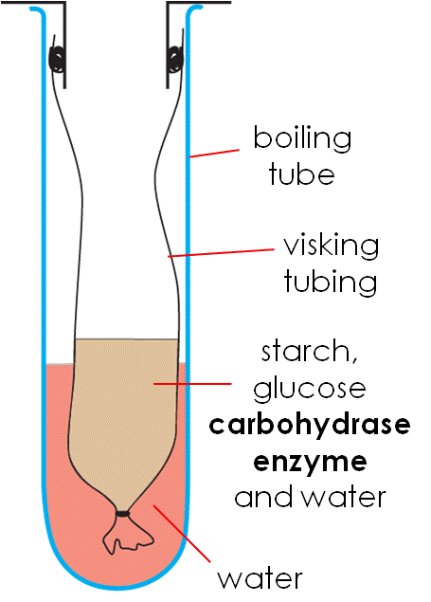
- In their next experiment they added a carbohydrase enzyme
to the mixture in the visking tubing.

They left the equipment for one hour.
Iodine is a liquid that can be used to detect the presence of starch.
It goes blue/black with starch and stays orange if there is no starch.
They added iodine to samples from the visking tubing
at the start and one hour later.
Explain how the test results would differ at these two times.
4 marks
- Sam is a sprinter. Before a race his coach advises him
to drink a sports drink that contains glucose.
Why is glucose the best nutrient to take before a race?
2 marks
- George is a long distance runner. Four hours before his race
he eats porridge and toast, which are both good sources of starch.
What will happen to the starch molecules?
4 marks
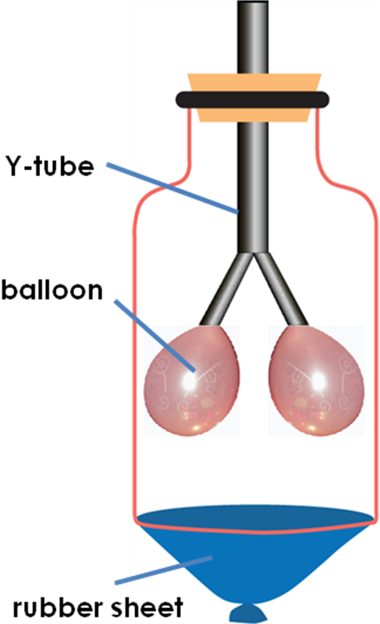
Academy quiz part 2
AF1 level 6 cells context
- Apparatus like the one on the right can be used to model lungs. When the rubber sheet is moved in and out, air enters and leaves the balloons. But real lungs are not hollow like balloons.
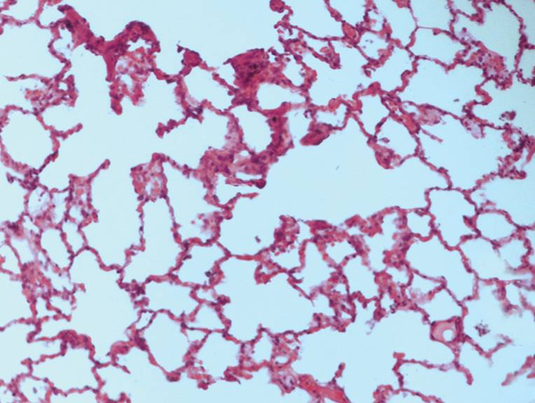
The microscope image below shows what lungs are really like – full of thin-walled air pockets.

Explain why a lung full of alveoli takes in oxygen faster
than a hollow lung would.
2 marks
- Many adults think respiration is something lungs do.
Explain what respiration really is and where it takes place.
5 marks

- Cells like these cover the villi in the small intestine.
A rare inherited disease makes some babies unable
to make them. They die of starvation soon after birth.
Explain why the cells are so important.
3 marks
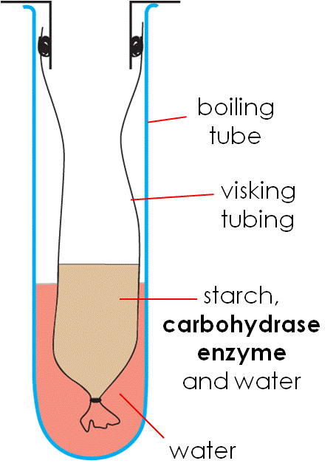
- The diagram below shows a model of starch.
When the apparatus on the right was left
for an hour, the starch disappeared.
Explain what happened to it.
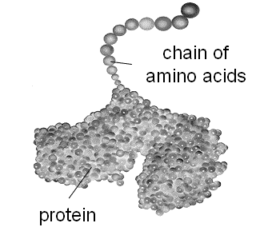
3 marks
- Explain why only one of these nutrients needs digesting.
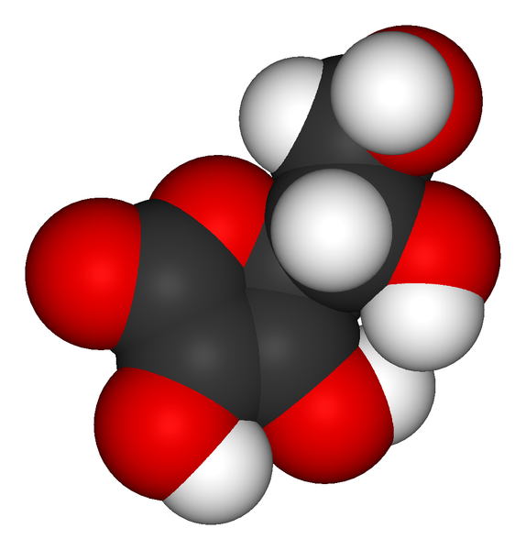
a. vitamin C b. minerals like c. protein
calcium
5 marks
- What do proteins turn into when they are digested?
2 marks
Academy quiz part 2
AF1 level 7 cells context
- Olympic swimming champion Michael Phelps has a lung volume
of 12 litres, which is more than twice the average person’s.
Explain why that helps him to take in oxygen faster.
2 marks
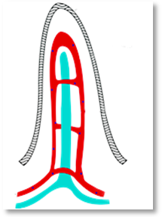
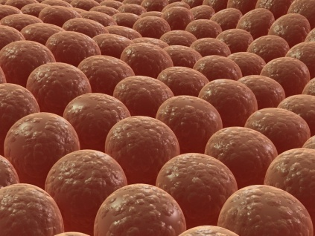
- The villi in your small intestine have blood running through them.
It carries away the digested food that diffuses into them.

When you exercise, more blood is sent to your muscles and less to your villi.
Explain why glucose diffuses into your blood more slowly
when your muscles are working hard.
3 marks
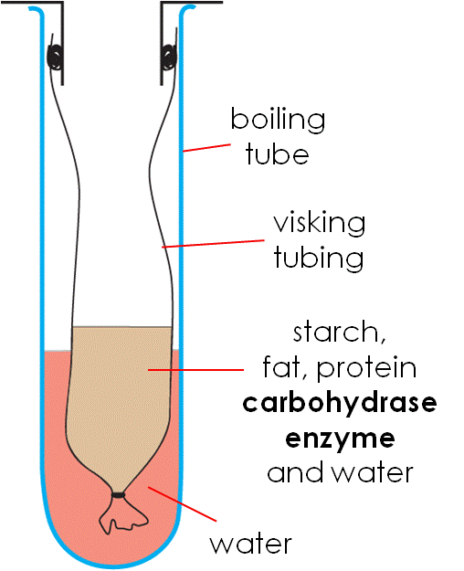
- When the apparatus on the right was left for an hour, the starch disappeared from the visking tubing, but
the amount of fat and protein didn’t change.
Explain why. 3 marks
- Everyone is advised to eat plenty of fruit and vegetables.
One thing they give us is fibre, which helps prevent constipation. Most of the fibre is eventually
flushed down the toilet.
Explain why we can’t extract nutrients from it.
2 marks
Academy quiz part 2 answers
Scoring points are separated by commas, and suitable keywords are in bold.
AF1 level 5H drugs context
- a. B
b. D
c. B and C
d. alveoli 4
- Cilia/ciliated cells, which wave/move backwards and forwards
to clear mucus plus trapped dirt/microbes from the lungs. 4
- a. Allow diffusion/gas exchange, between blood and air. 2
b. Large surface area, and good blood supply. 2
- a. oxygen
b. carbon dioxide 2
- Covered in villi, which provide a large surface area. 2
- a. glucose
b. starch molecules are too big 4
- At the start, iodine would go blue/black because starch is present.
At the end the iodine would stay brown because the starch has
broken down/been digested. 4
- Glucose molecules are small, so they don’t need digesting/can
be absorbed quickly into the blood. 2
- The starch molecules will be broken down/digested to make
glucose molecules, which will pass through into his blood
and be carried to his muscles/cells/tissues. 4

Total = 30 marks

AF1 level 6 drugs context
- Alveoli provide a large surface area, for gas exchange. 2
- Respiration is a chemical reaction, which releases energy,
from glucose and oxygen in every cell. 5
- The microvilli on these cells, provide a large surface area,
so they speed up the nutrient/glucose uptake. 3
- The starch was broken down/digested, by the carbohydrase
enzyme, to make glucose. 3
- The vitamin C and calcium are small enough or amino acids are
too large, to pass through the wall of the small intestine. 5
- Amino acids 2
Total = 20 marks

AF1 level 7 drugs context
- His lungs provide a greater surface area for gas exchange, which
allows faster diffusion between the air spaces and blood. 2
- When less blood is sent to the villi, nutrient uptake drops, because diffusion is slower when nutrient-rich blood is not carried away. 3
- The starch was broken down/digested, by the carbohydrase
enzyme, but there were no lipase or protease enzymes present or carbohydrase is not able, to break down the fat and protein. 3
- We have no enzymes, that can digest/break down fibre. 2

Total = 10 marks

