Academy quiz part 1 answers
AF1 level 3 cells context
- Choose the correct description of respiration.
  - moving air in and out of the lungs
  - releasing energy from glucose and oxygen
  - taking in oxygen and breathing out carbon dioxide.
1 mark
- As the runner speeds up his muscles release
more energy, and his lungs take in more oxygen.
List two ways his breathing changes.
Answer: It gets faster and deeper.
2 marks
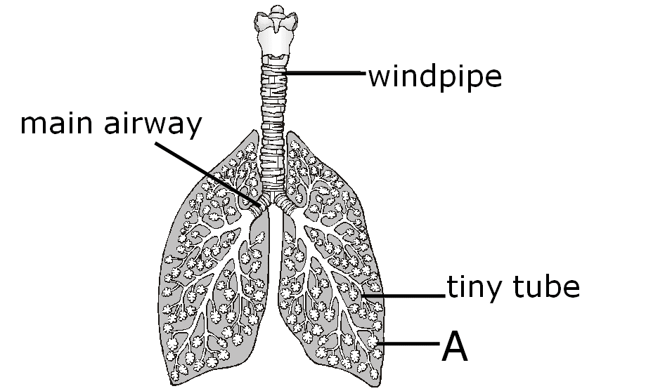
- This diagram shows the main part of the lungs.
a. what are the parts labelled A? alveoli
b. which two parts are protected by a thin layer of mucus?
Answer: The windpipe and main airway
3 marks

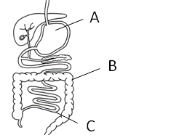
- The diagram on the right shows the
parts of your digestive system.
Which is the small intestine? C
1 mark
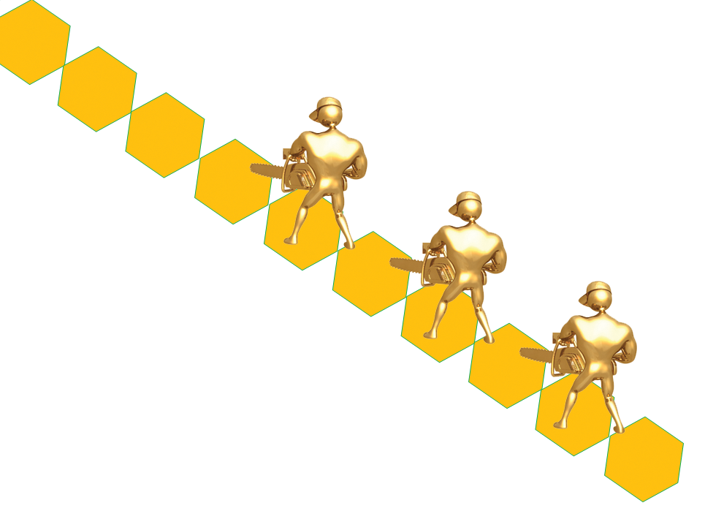
- In the small intestine, big molecules are
broken down to make smaller ones.
What do the workers breaking down this
molecule represent?
Answer: Enzymes
1 mark
- Which three nutrients are made from large molecules?
fat glucose protein vitamins carbohydrate (starch)
3 marks
- How many types of enzyme does your digestive system make?
Answer: 3
1 mark

- Nutrients are used as energy sources and as raw materials
for growth and repair. Which three are nutrients?
minerals water glucose fibre starch
3 marks

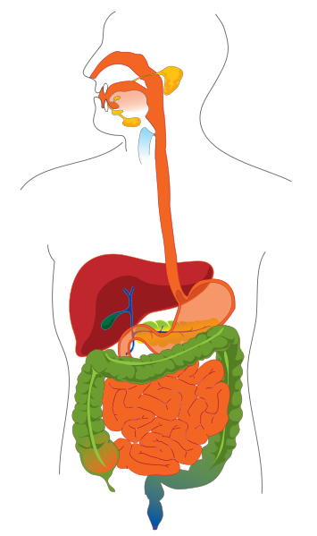
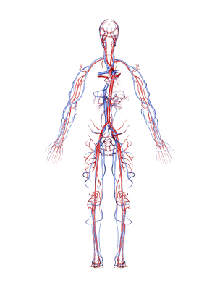
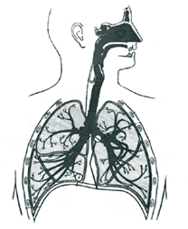
- Name these three organ systems.
A
circulatory
system
C
digestive
system
B
respiratory
system
3 marks

- What job does your circulatory system do?
Answer: It pumps blood to every tissue/cell
to deliver nutrients and oxygen and removes waste.
2 marks

Academy quiz part 1 answers
AF1 level 4 cells context
- Finish this word equation for respiration
oxygen + glucose → carbon dioxide + water 3 marks
- Where do these go when they leave your small intestine?
  - digested food like glucose
Answer: Through the intestine wall, into blood/a capillary, to cells.
  - undigested food like fibre
Answer: Into the large intestine, and out as faeces. 2 marks
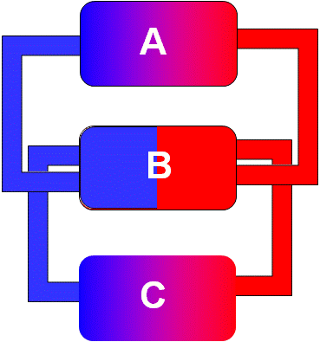
- Louise drew a diagram
to explain circulation.
Part C represents most
of the body’s cells.
  - What labels should
she put on A and B?
A: Lungs B: Heart
  - Name the waste gas
blood carries from
C to A.
Answer: Carbon dioxide 3 marks

- What do these organ systems add to your blood?
  - respiratory system – oxygen
  - digestive system – nutrients (glucose, carbon dioxide)
2 marks
Academy quiz part 1 answers
AF1 level 5L cells context
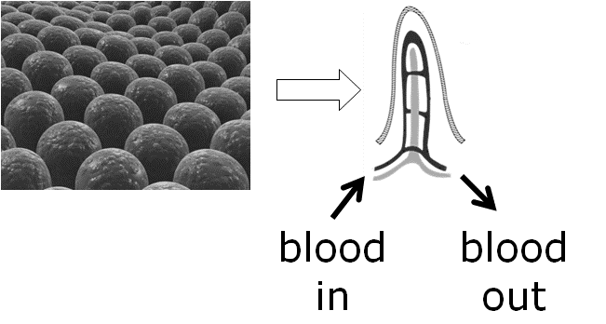
- Villi are specialised tissues found in the small intestine.
How is the blood that leaves them different from
the blood that enters them?
Answer:
It contains more nutrients/glucose (and carbon dioxide but less oxygen).
1 mark
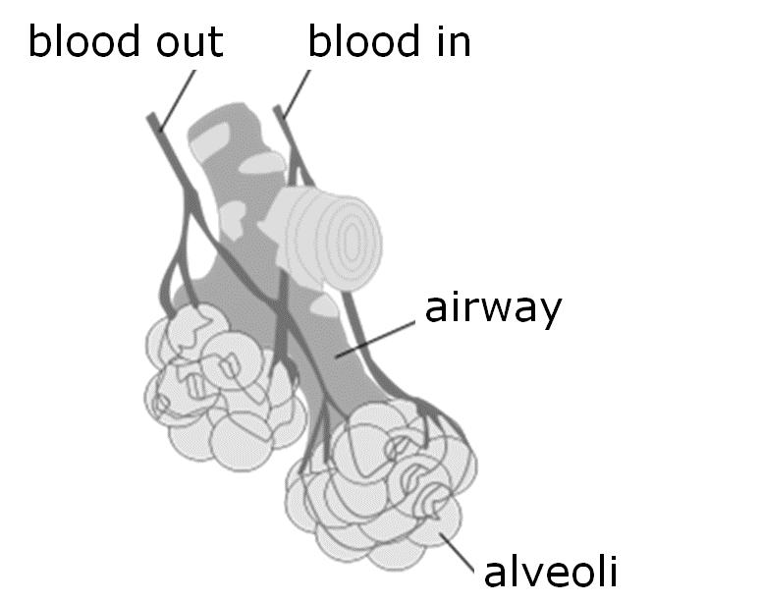
- Alveoli are specialised to allow efficient gas exchange.
How is the blood that leaves them different from
the blood that enters them?
Answer:
It contains more nutrients/glucose (and carbon dioxide but less oxygen).
2 marks
- Which sentence applies to oxygen?
  - its percentage is lower in the alveoli so it diffuses out of your blood
  - its percentage is higher in the alveoli so it diffuses into your blood
1 mark
- Put these statements into the correct order to explain why lungs take in oxygen and remove carbon dioxide.
The air we breathe is 20% oxygen, 0.04% carbon dioxide
- so oxygen diffuses into the blood in your lungs
  - your heart pumps oxygenated blood to muscles and other tissues
  - muscles and other tissues use oxygen and produce carbon dioxide
  - carbon dioxide made in muscles and other tissues enters the blood
- your heart pumps blood with extra carbon dioxide to your lungs
- only 0.04% of the air is carbon dioxide, so it diffuses out of the blood
The air we breathe out has about 16% oxygen, 4% carbon dioxide
6 marks

